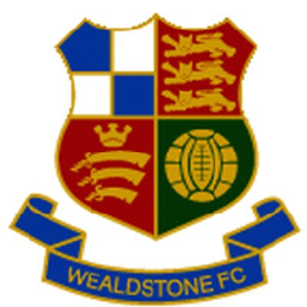
Wealdstone FC
Junior Liaison Role:

Overview
With one of the largest fan bases in Non-League football, a first team playing in the newly rebranded Vanarama National League South, three ladies’ teams and a youth structure providing coaching to over 500 registered players across 35 teams ranging from Under 7 to Under 18, Wealdstone Football Club is one of the fastest growing and most successful non-league football clubs in London. Wealdstone are an innovative and ambitious club and have established themselves as a firm part of the local community in the Ruislip and surrounding area since 2008.

Key responsibilities

- Establish and maintain Junior Stones for U16’s with membership, offers and much more.
- Find Mascots for all 1st team home fixtures.
- Find and maintain a list of Ball boys for 1st team home fixtures.
- Work closely with the Youth set up to establish and maintain links for 1st team games.

Experience or Interest:

- Strong coordination skills,
- Excellent copywriting skills.
- Must have DBS/CRB ‘Standard’ certificate
- Interested in working with the community and developing the club’s interests.
- To apply to this role, please send a quick email to craigwhitehead@wealdstonefc.com

